QTY EACH |  | IMAGE | PRODUCT NUMBER UPC 12 | NAME | WHOLESALE PRICE | TOTAL
 |  | 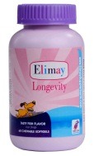 | 8904092314002 | Longevity  60 Gel-Capsules | $19.97
 |  | 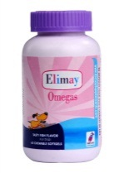 | 8904092314033 | Omegas  60 Gel-Capsules | $10.53
 |  | 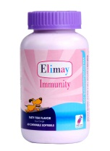 | 8904092314019 | Immunity  60 Gel-Capsules | $19.97
 |  |  | 8904092314026 | Detox  60 Gel-Capsules | $34.97
 |  | 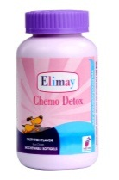 | 8904092314088 | Chemo Detox  60 Gel-Capsules | $54.97
 |  | 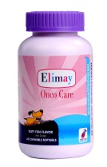 | 8904092314095 | Onco Care  60 Gel-Capsules | $66.06
 |  | 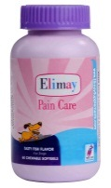 | 8904092314507 | Pain Care  60 Gel-Capsules | $14.41
Total: |  |  |  |  | Total:
www.ElimaySupplements.com
www.elimaysupplements.com
Order Form
www.elimaysupplements.com
Order Form
I hereby authorize Elimay Supplements to bill my credit card for the goods purchased.

Business Information
Name of Business: Telephone:
Business Address: City: State: Zip:
Veterinarian Name: Email:
Order Placed By
Name: Title:
Credit Card Information
Payment Method (please circle): VISA MASTER CARD CHECK BILL MY ACCOUNT
Name on Credit Card:
Credit Card Number: Expires: Security Code:
Billing Address: City: State: Zip:
Sales taxes are not charged to wholesale buyers/vendors. A wholesale buyer/vendor engaged in making retails sales are expected to subject buyers to a sales tax at the fixed location when selling products to the end consumer. Wholesale buyers/vendors are to send the added tax to their local government appropriately.
Customers Account Number Direct Bill:
Customers Signature: Date:
Fax Order To: Attention Laura Riehl : (317) 713-2950 • Elimay Customer Service: 1-855-440-3582
www.ElimaySupplements.com

